ECMS
Log in PCA;
- Go to Post Clearance Audit
- Click Create General Audit
- Fill up all the details;
Audit details dashboard
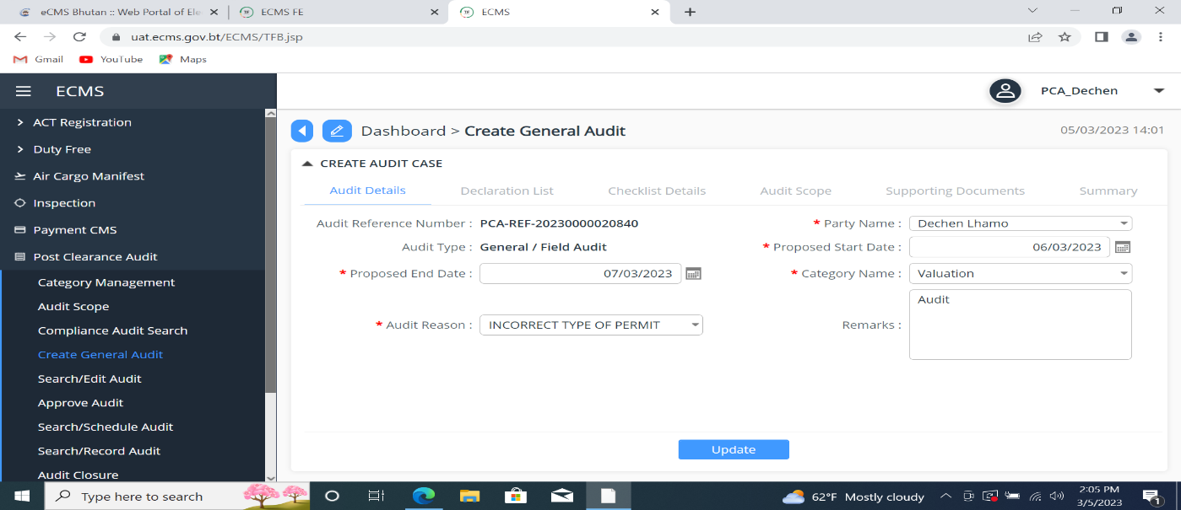

Declaration list dashboard
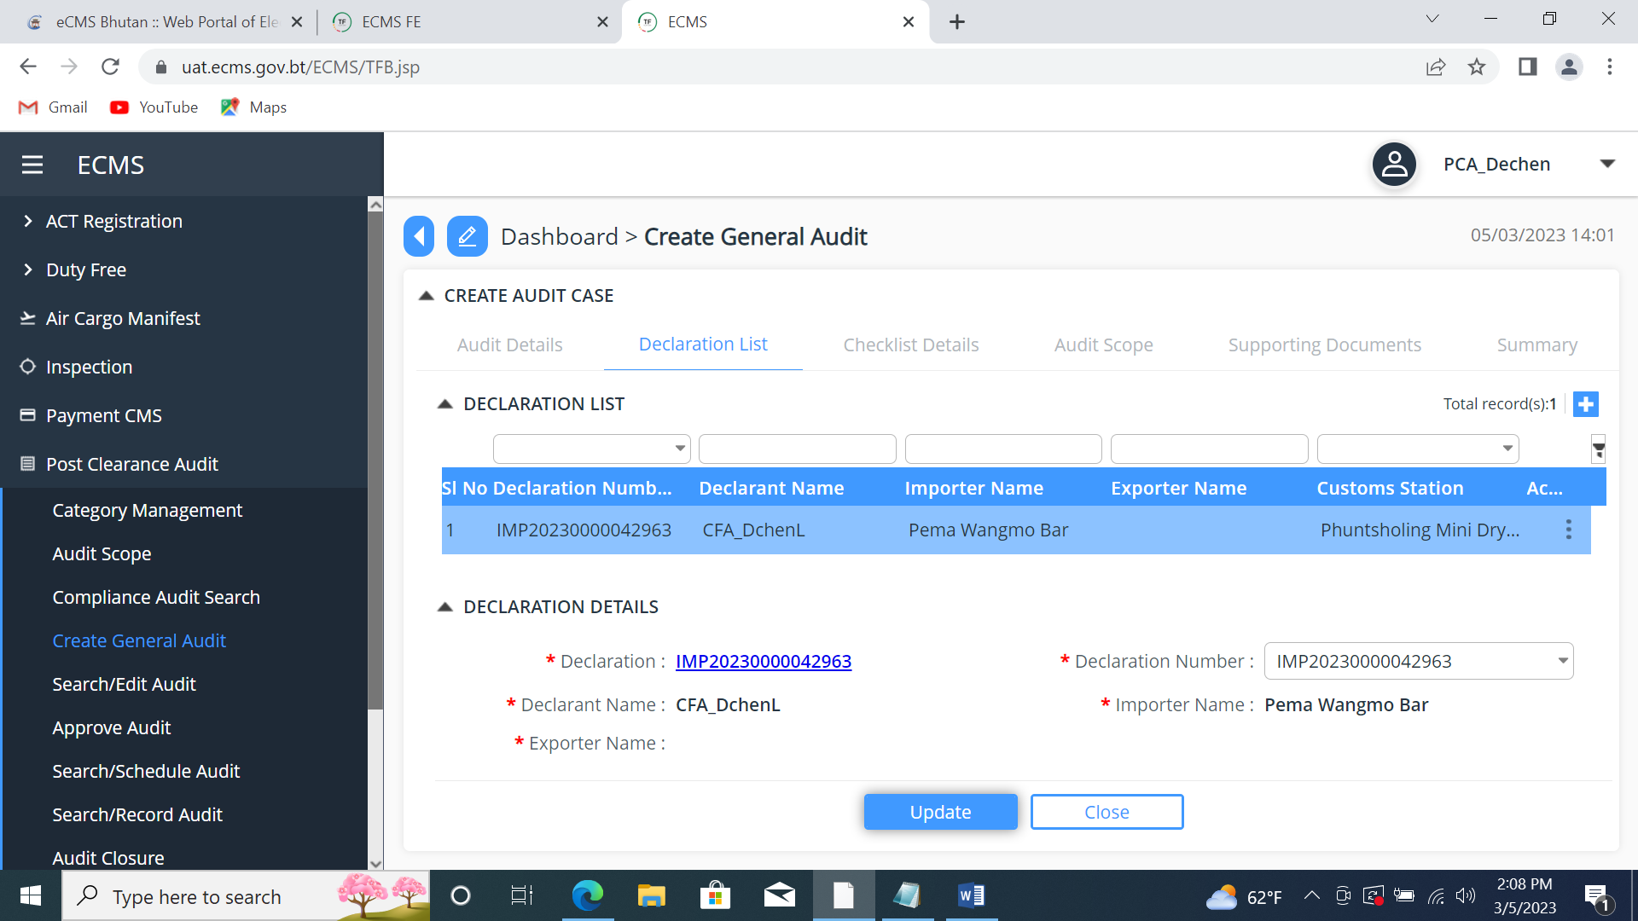

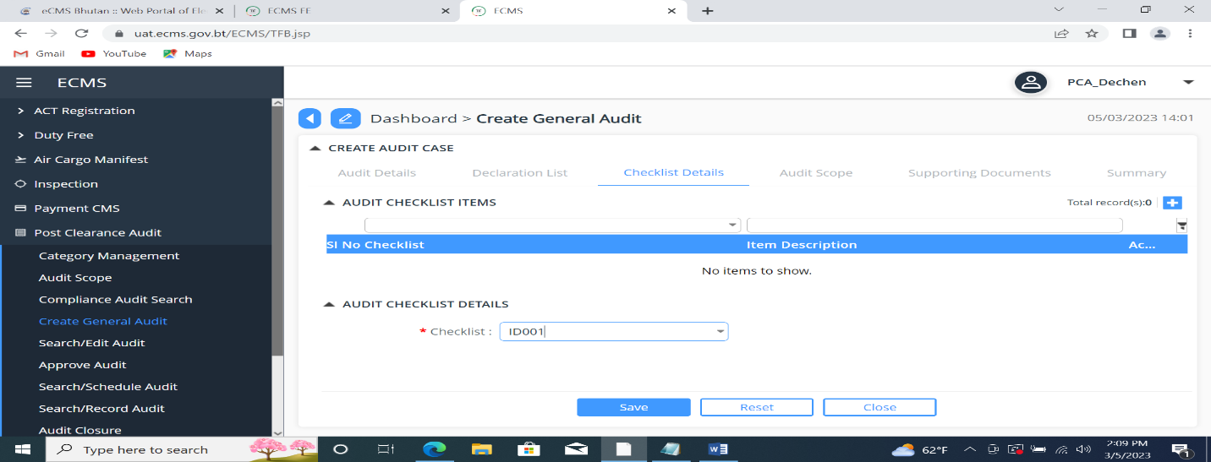
Checklist details

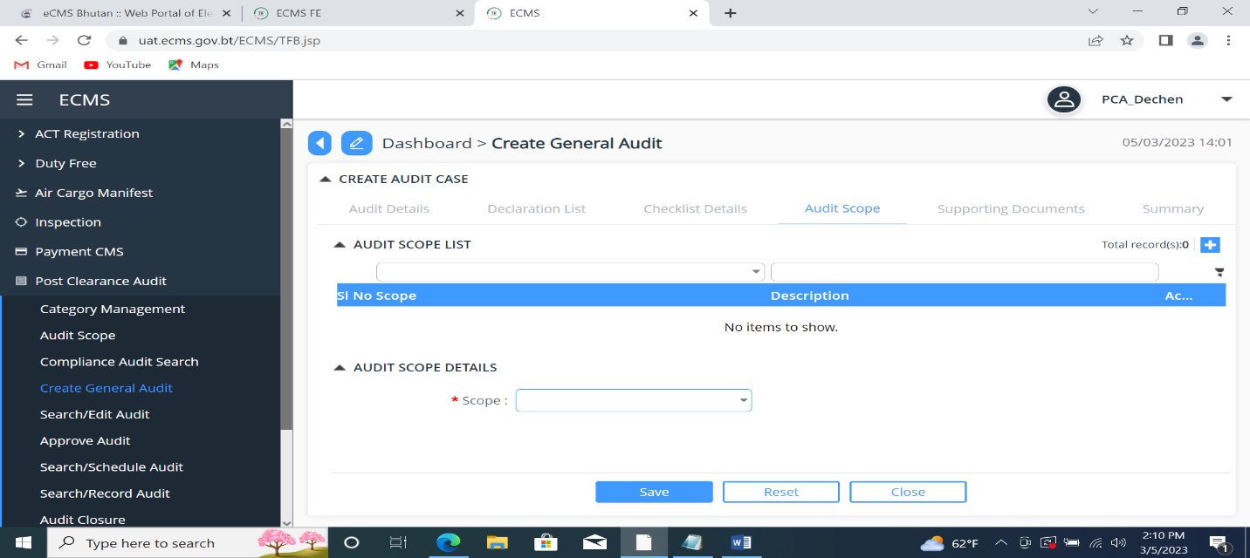
Audit scope

Supporting documents
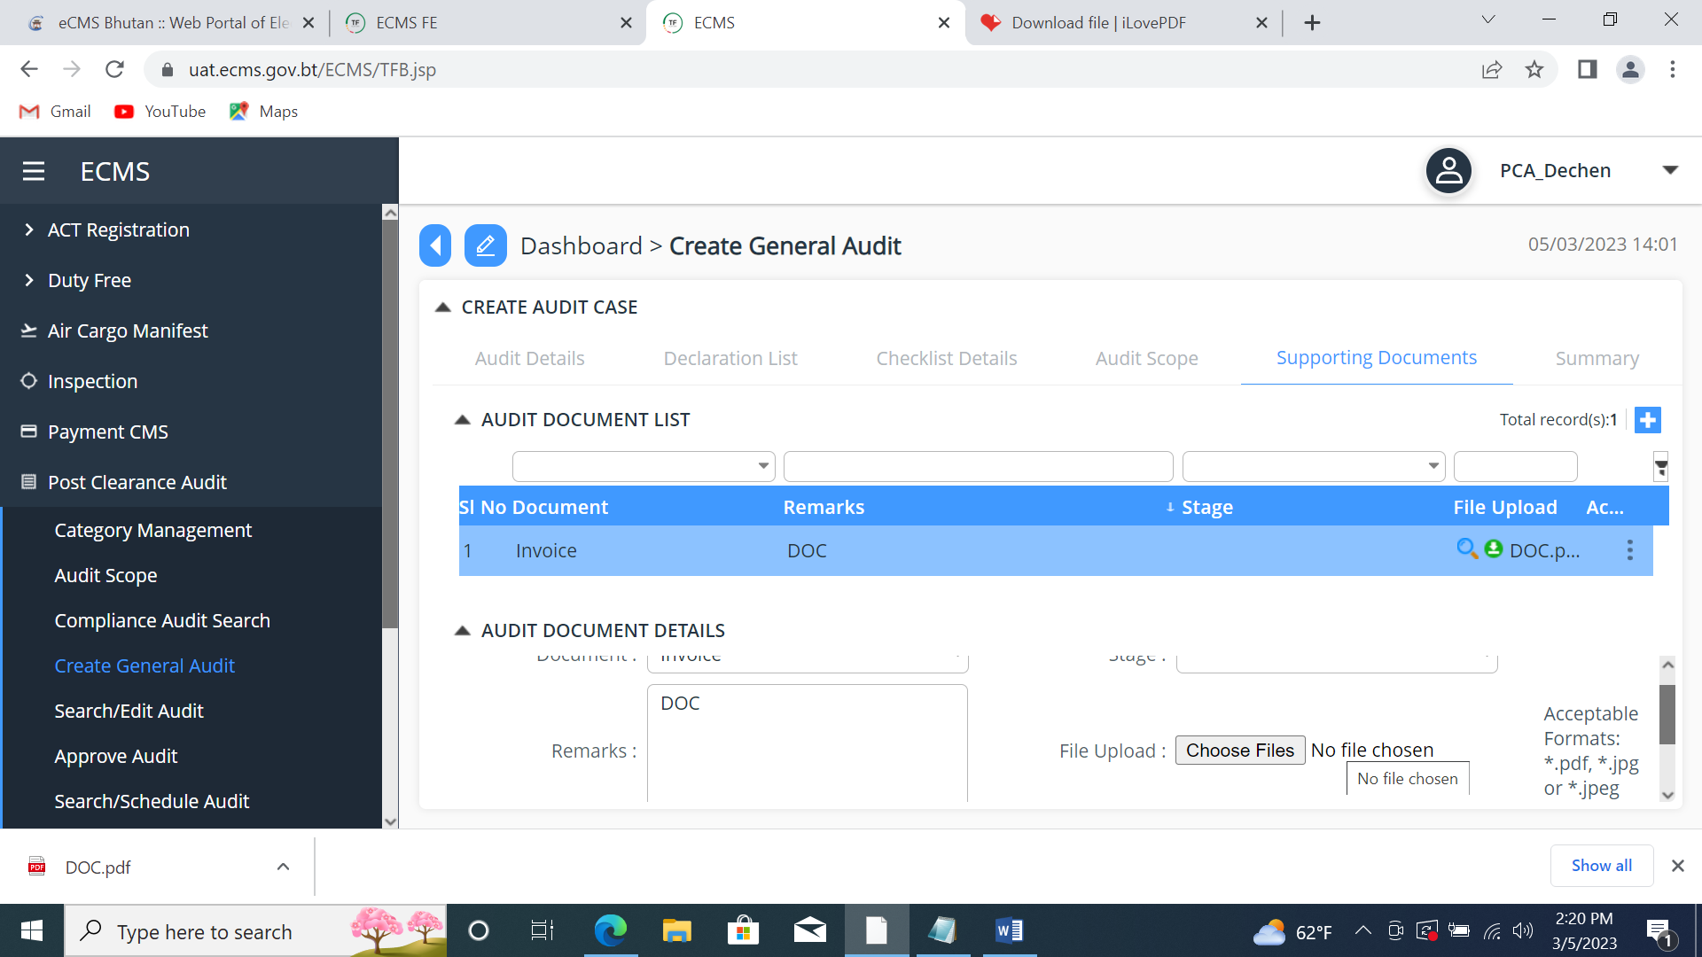
Summary
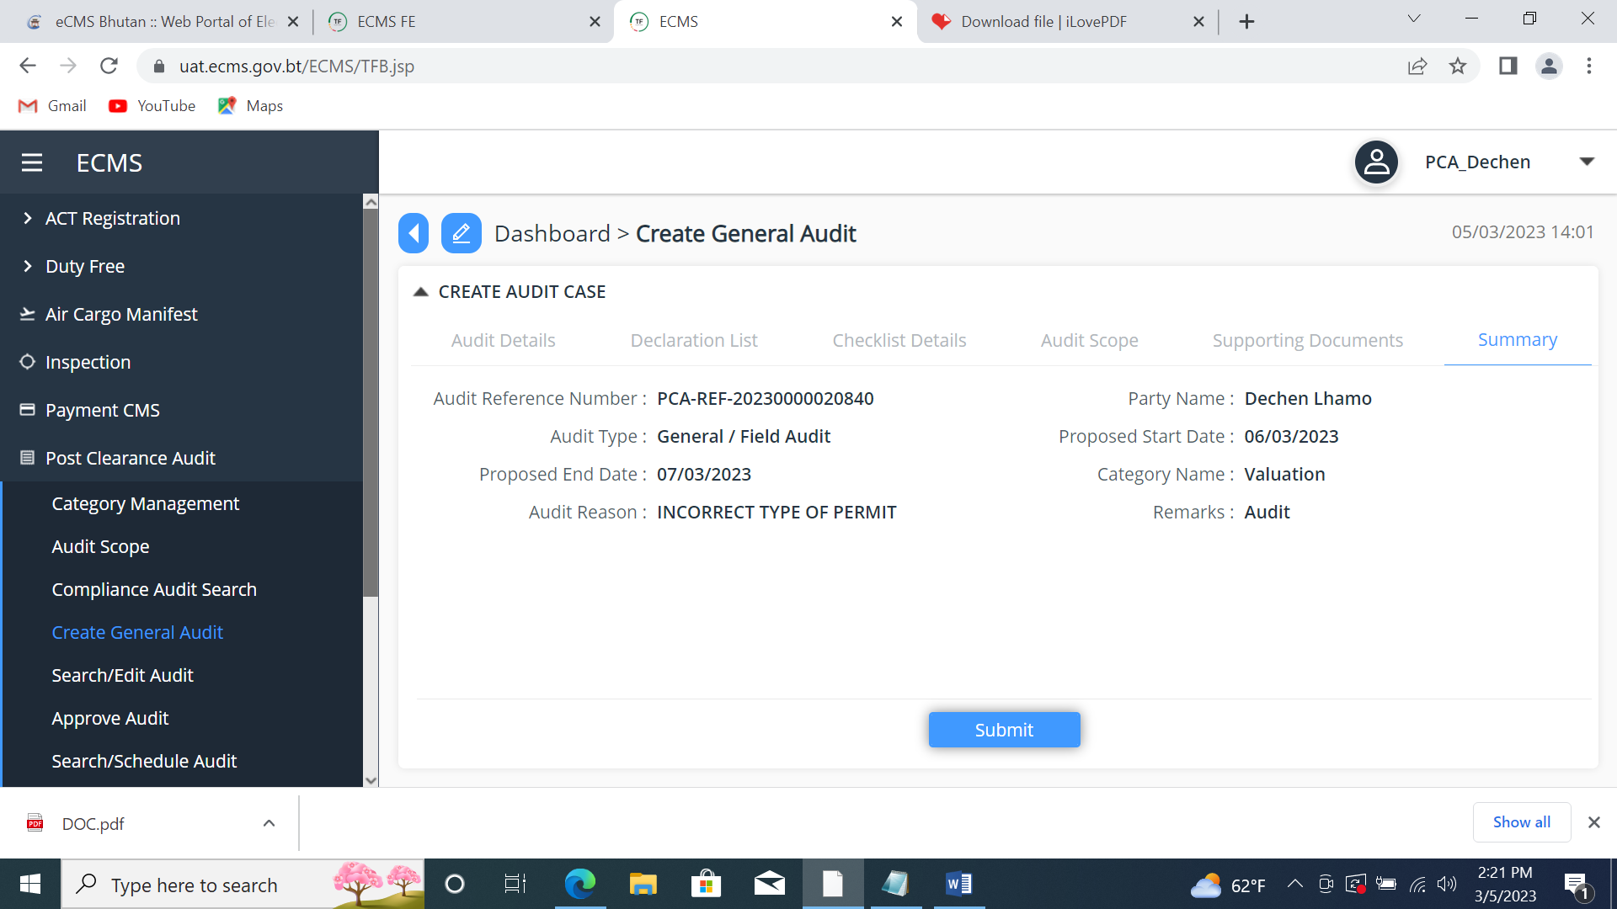
- PCA Ref. numbers appears.
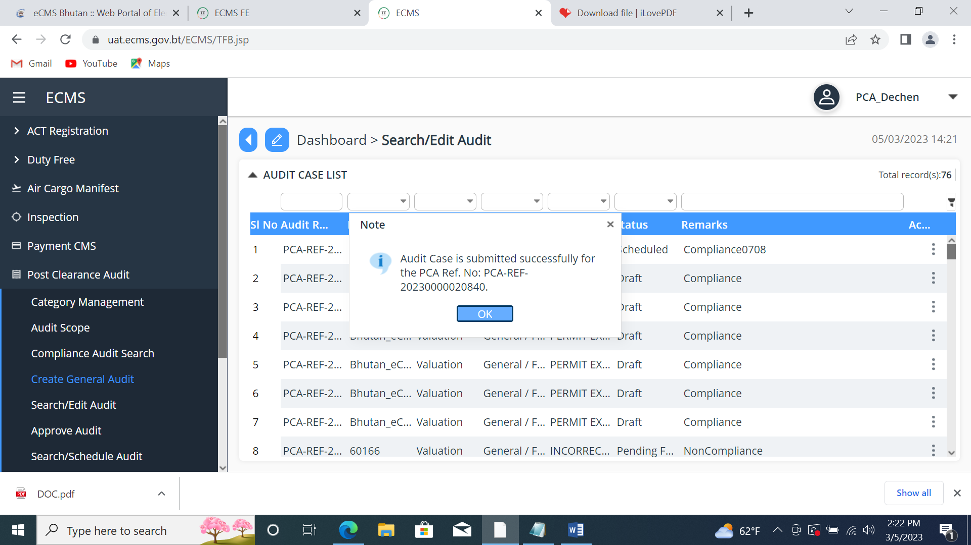

- Go to Search/Edit audit and paste the PCR ref. no. on the search panel.
- Check the status;
Pending for Approval
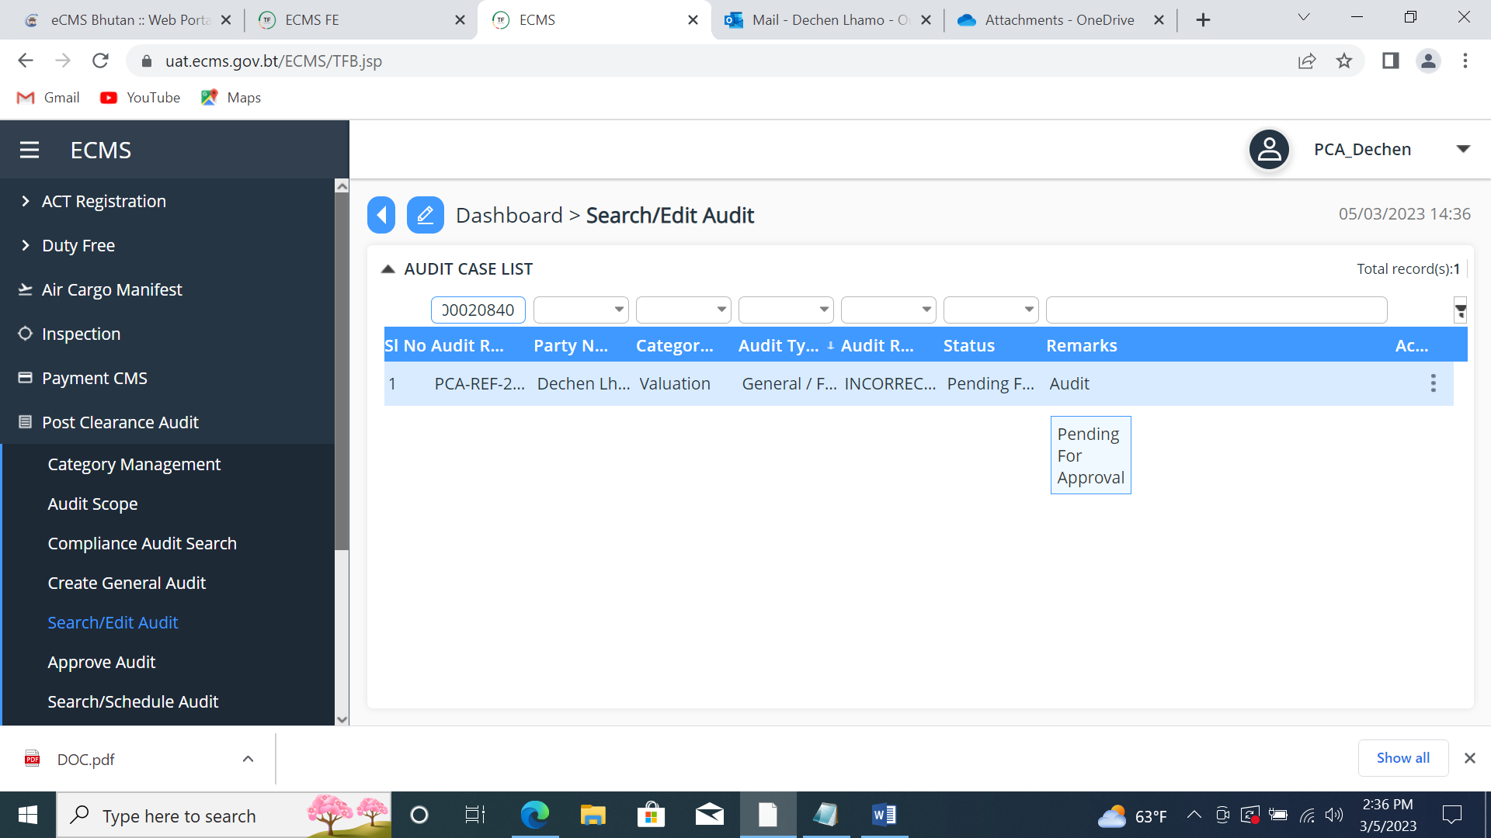

Login to Custom;
- Go to Post Clearance Audit.
- Click to Approve Audit
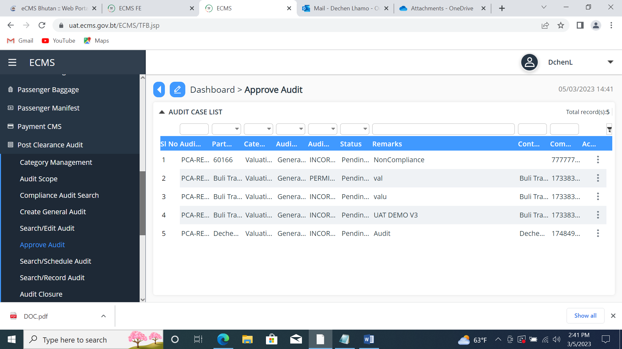
- Copy and paste the PCA ref. no. in the search panel.
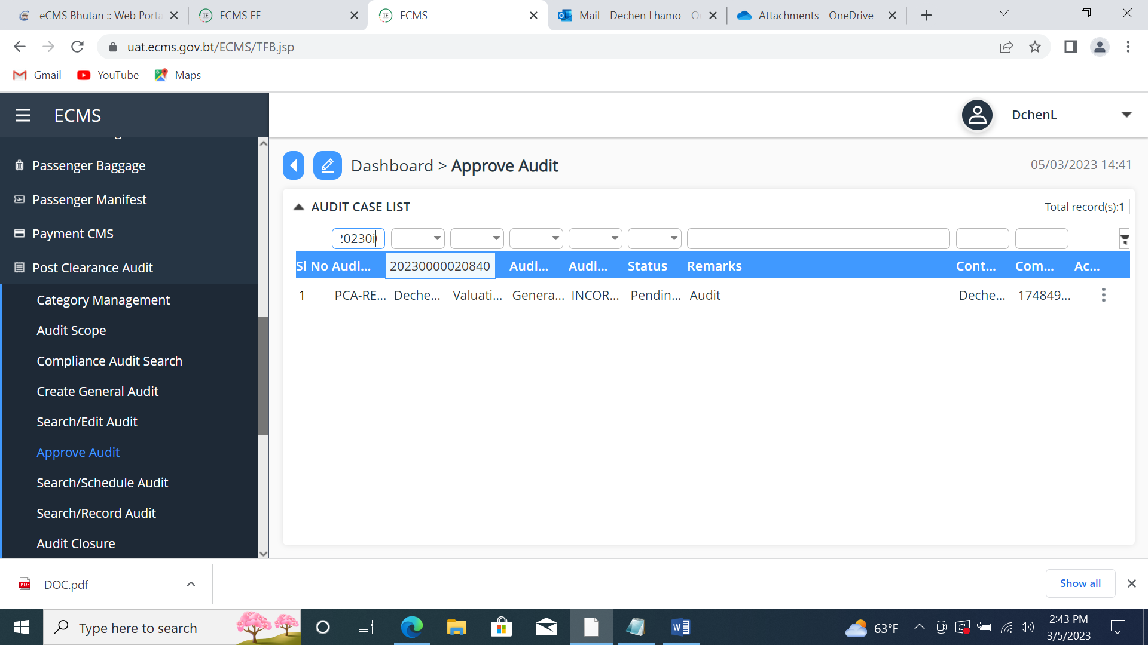
- Go to Approval, change the status as Approved and click the submit button.
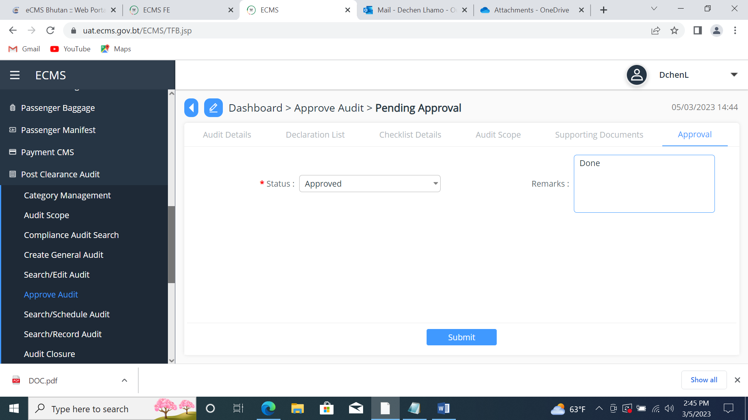
Login to PCA;
- Go to Post Clearance Audit
- Click to Search/Scheduled Audit, then go to scheduled audit and click the update button.
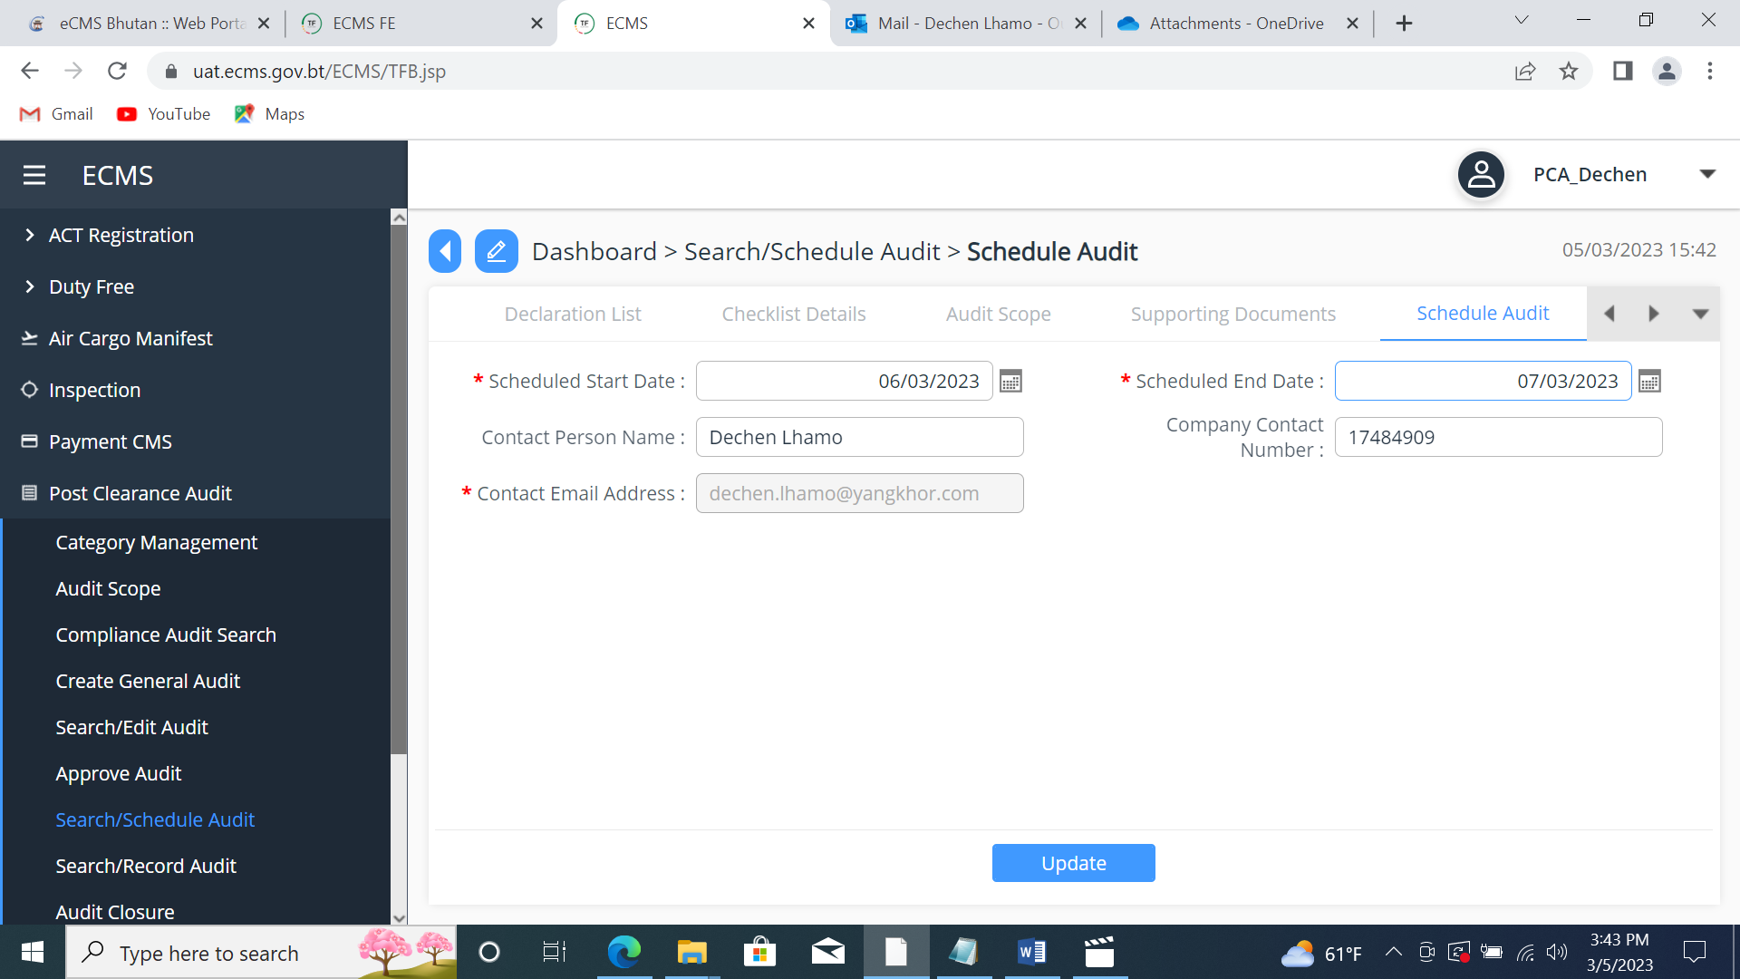
- Go to summary and click the submit button.
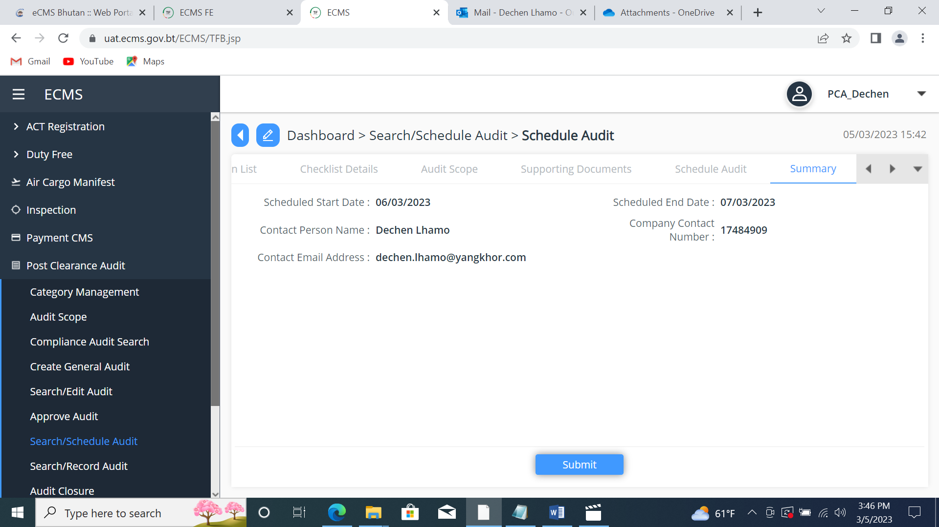
- PCA ref. number is given.
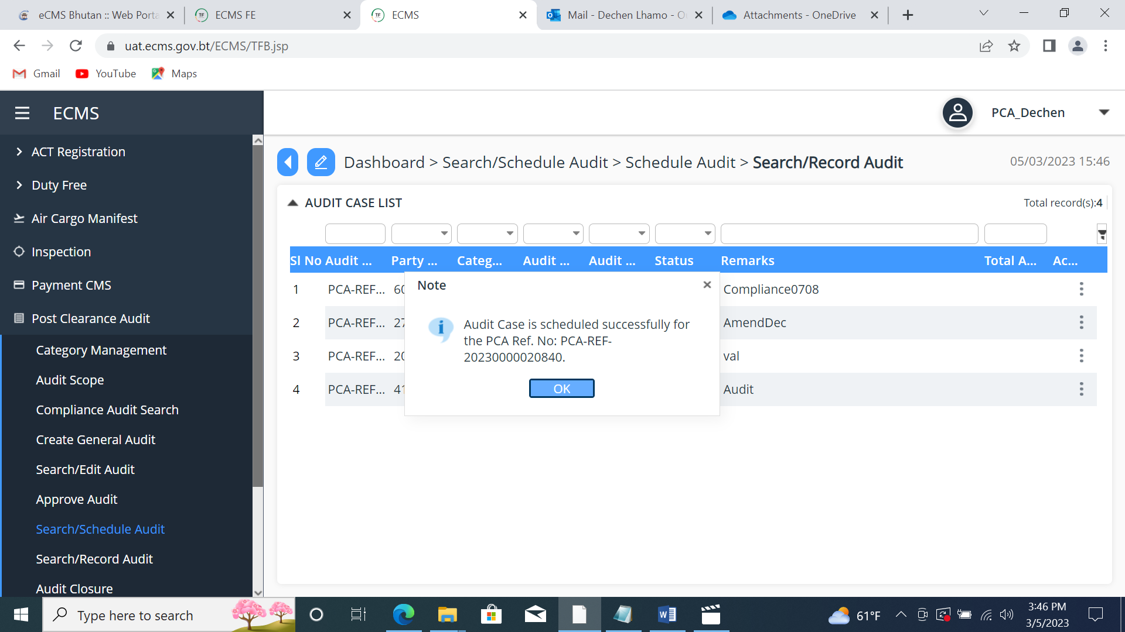
- Go to Search/Record Audit, paste the PCA ref no. in the search panel.
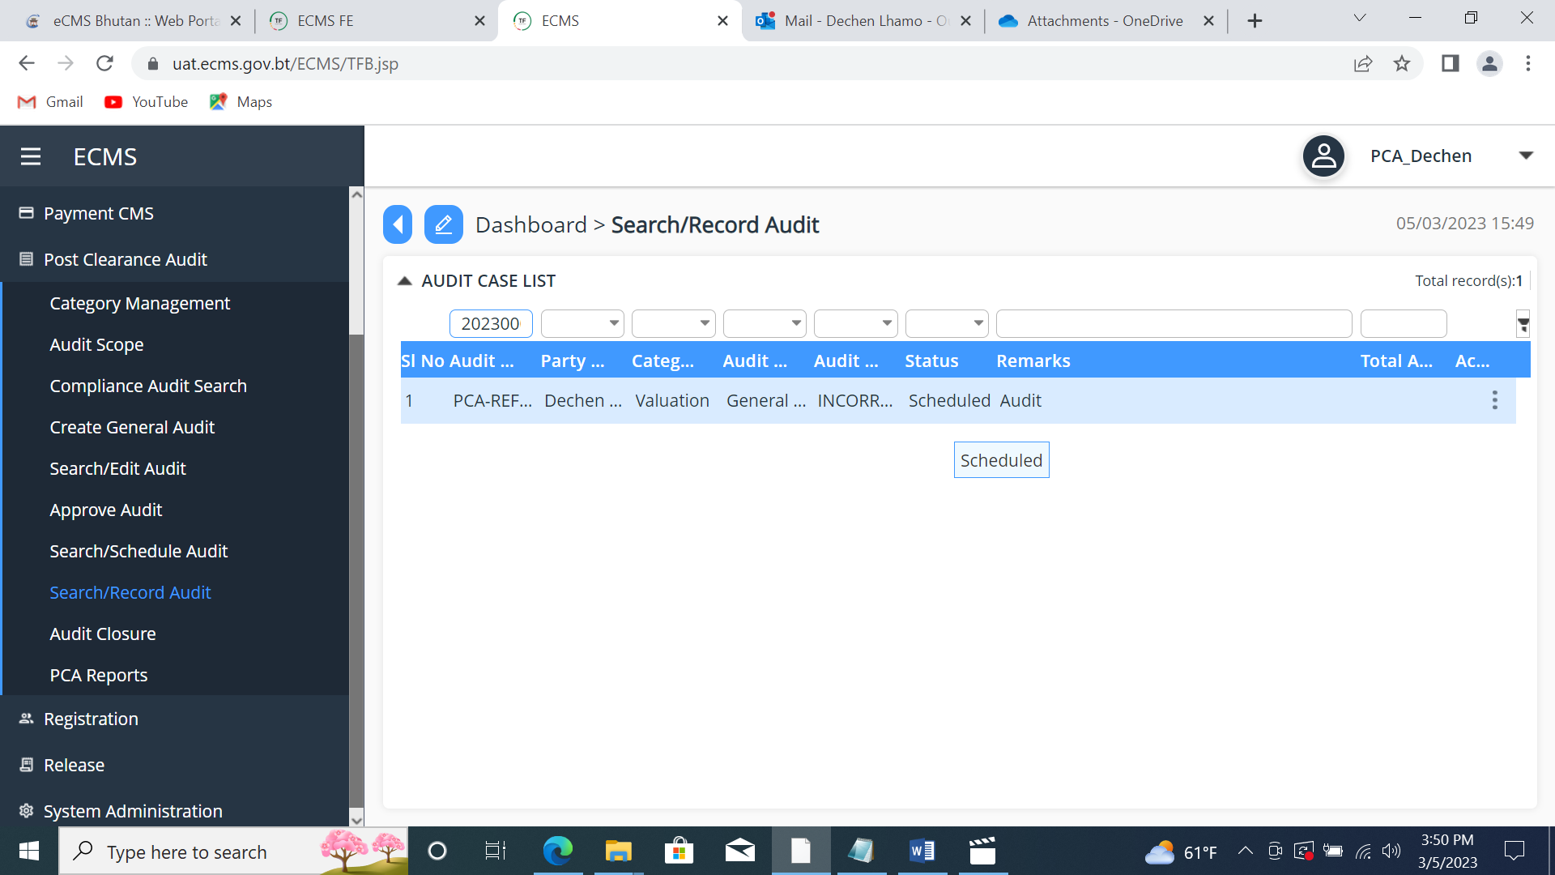

- Go to Audit result, fill up the details and click the save button.
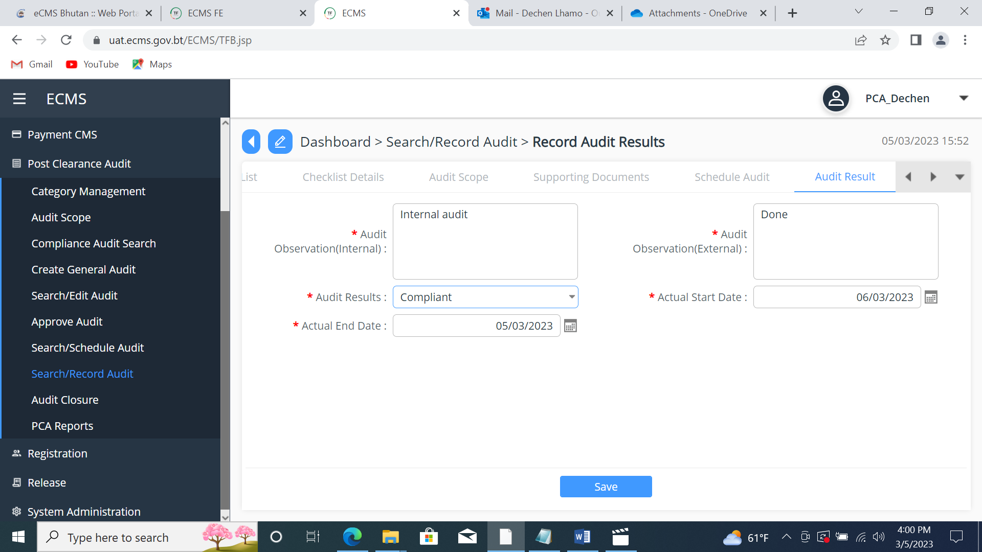

- Go to Demand note, click the add button;
- Fill the Demand note details and Demand note tax details as shown below:
Then click the save button.
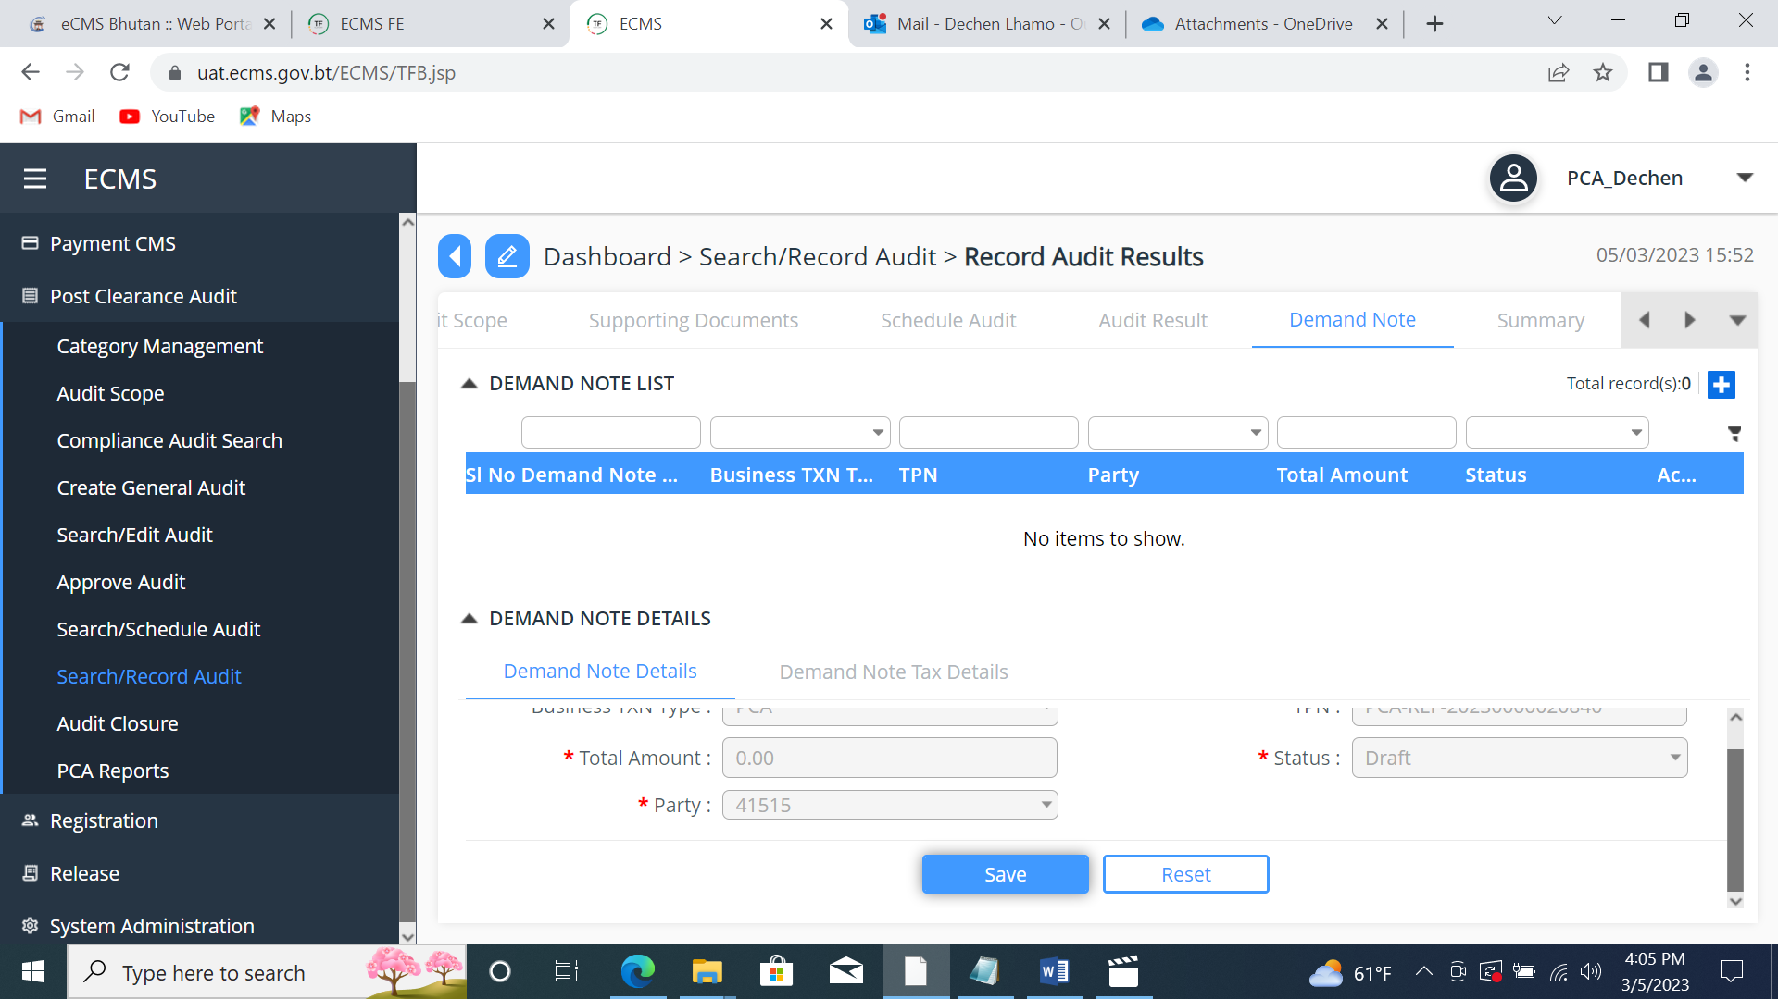

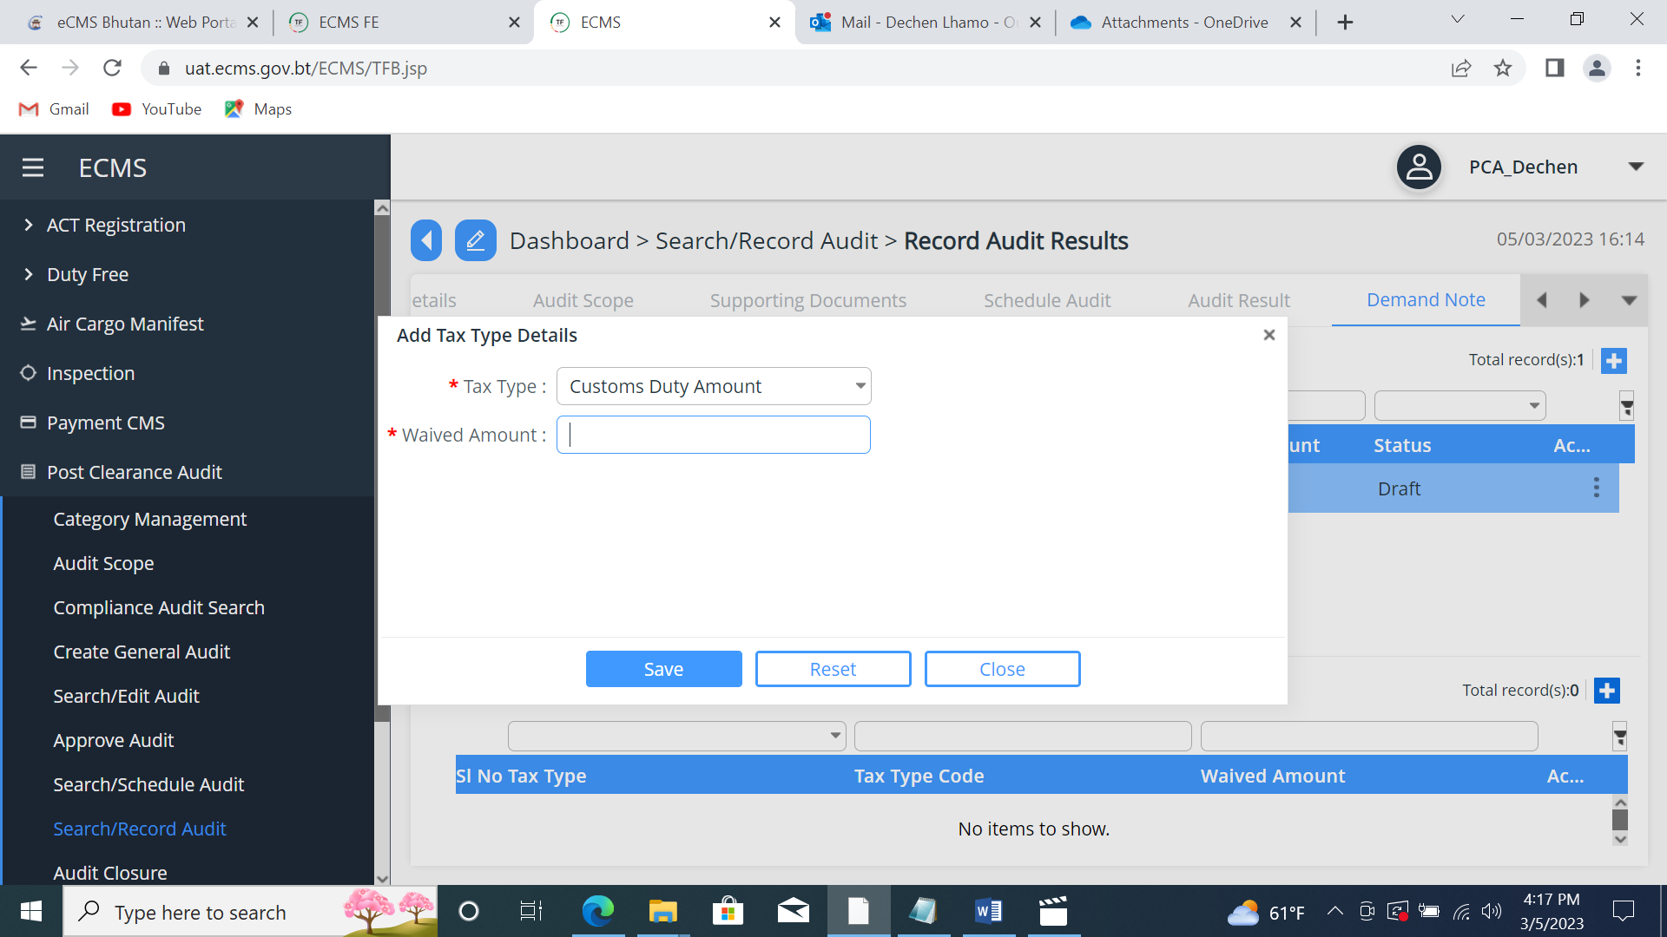

- Go to summary and click the submit button.
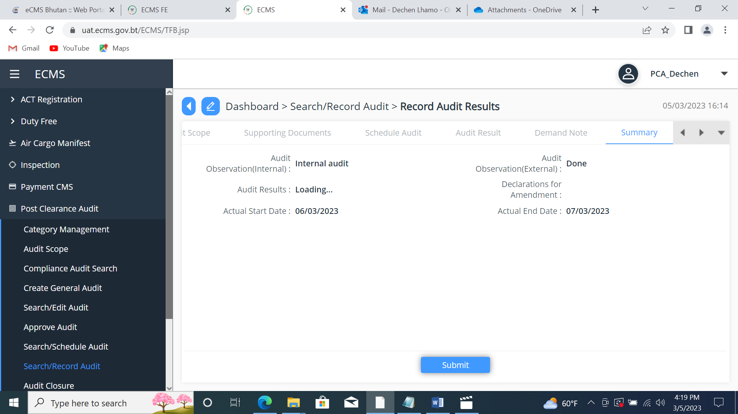
Log in Custom;
- Go to Post Clearance Agent
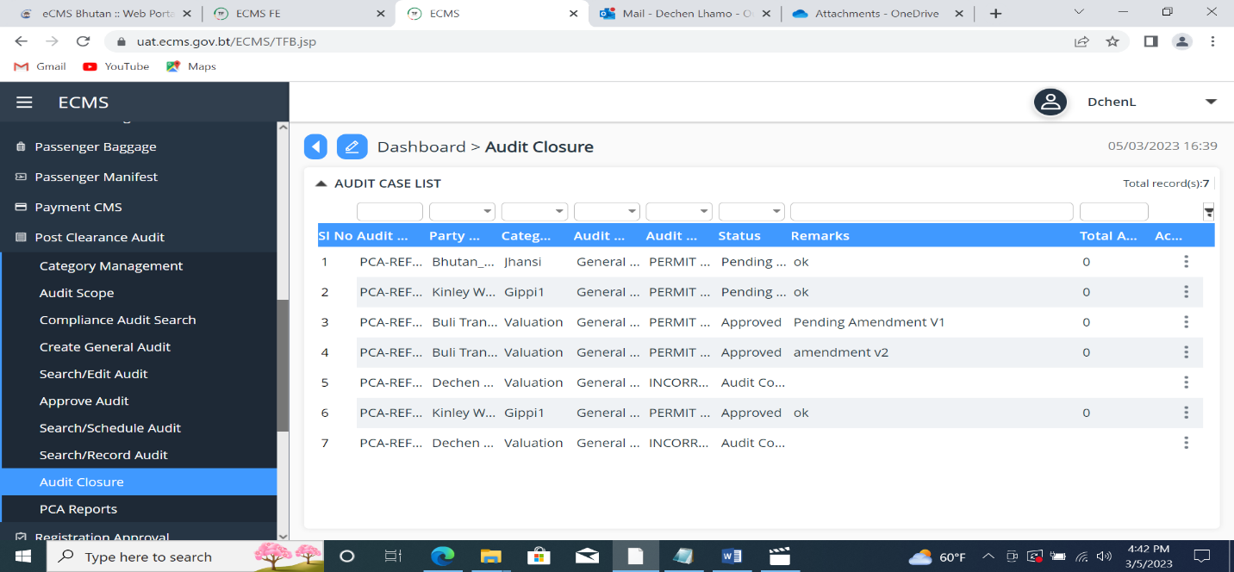
- Click Audit closure.

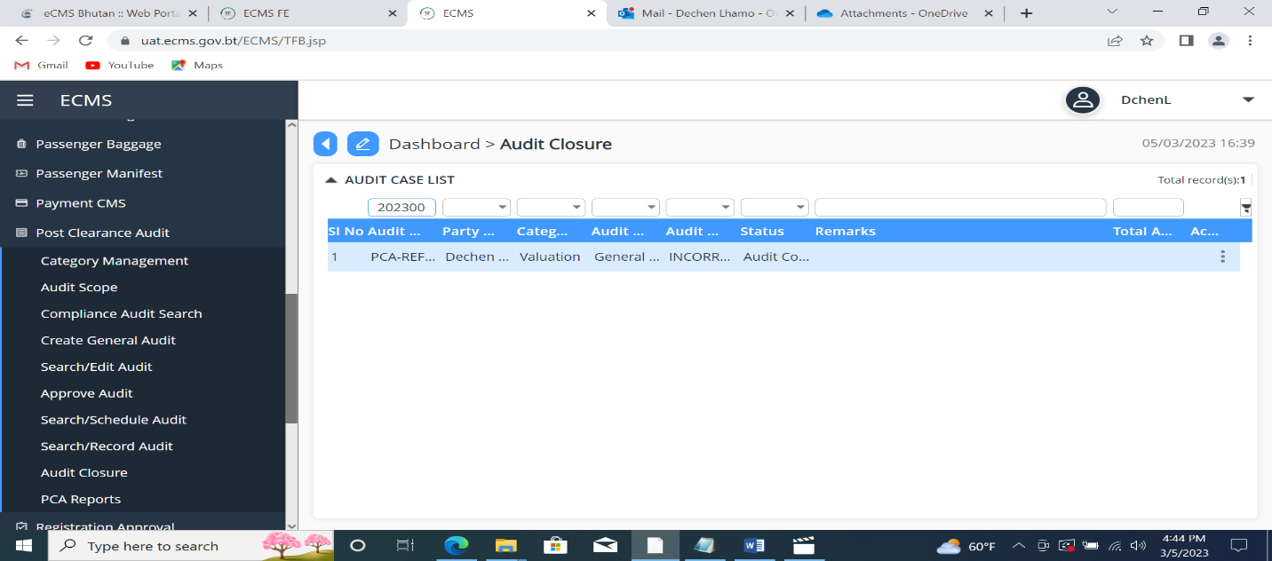
- Paste the PCA ref. number in the search panel.

- Go to Audit Approval, change the status as Approved and click the submit button.
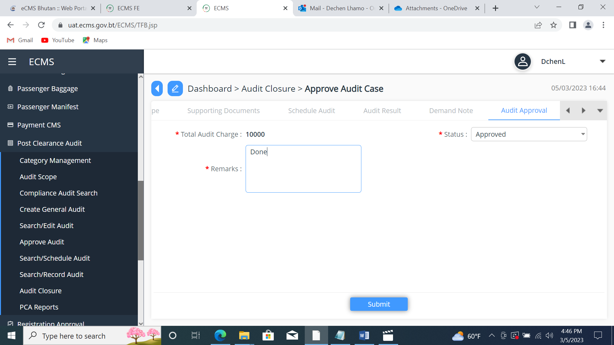

- Go to Search/Edit audit, search the PCA ref. number in the search panel.
(Status – ‘Closed’)
